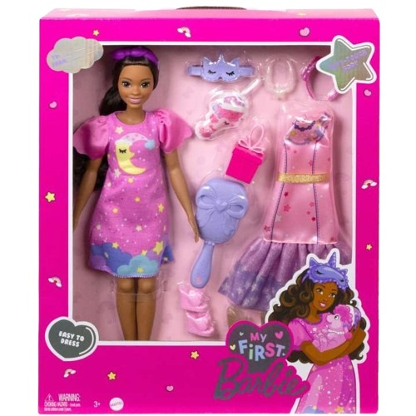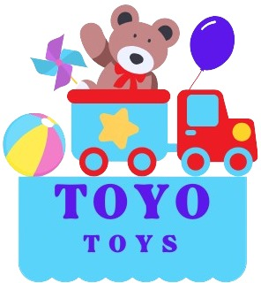

**My First Barbie**

**$9.99**

**Comes with simple, stylish outfits and accessories**

**Introduce your child to the magical world of Barbie with My First Barbie. Designed for younger kids, this doll is easy to play with, promoting nurturing, storytelling, and imaginative play**

**Product details**

**THANK YOU!**

**WELLCOME TO OUR WEBSITE**